NEW CLIENTS

Previous Address: |  | New Address Effective: 7/1/17 ***REVISED***
Grass Advantage, LLC  In-House  230 Newport Center Drive  Suite 300  Newport Beach, CA 92660  And  MPS  Dept. 781  P.O. Box 407  Cinnaminson, NJ 08077 |  | Grass Advantage, LLC  Inmar Dept. #29835  One Fawcett Drive  Del Rio, TX 78840
GS1 Company Prefix | UPC Company Prefix | Brand/Products | Family Codes
0829835 | 829835 | SuperFood | 000-999

Previous Address: |  | New Address Effective: Immediately ***REVISED***
Oregon Ice Cream, LLC  In-House  4600 North West Camas Meadows Drive  Suite # 100  Camas , WA 98607  And  JOIC/Universal  P.O. Box 222510  Hollywood, FL 33022 |  | Oregon Ice Cream, LLC  Inmar Dept. #72609  One Fawcett Drive  Del Rio, TX 78840
GS1 Company Prefix | UPC Company Prefix | Brand/Products | Family Codes
0072609 | 072609 | Julie’s Organic Ice Cream | 000-999

Previous Address: |  | New Address Effective: 7/20/17
Green Park Snacks  New Couponer  1601 Colorado Avenue  Santa Monica, CA 90404 |  | Green Park Snacks  Inmar Dept. #50126  One Fawcett Drive  Del Rio, TX 78840
GS1 Company Prefix | UPC Company Prefix | Brand/Products | Family Codes
0850126007 | 850126007 | Green Park Snacks (Hippeas) | 000-999

Previous Address: |  | New Address Effective: 8/1/17
Good Day Chocolate  New Couponer  1035 Pearl Street  Boulder, CO 80302 |  | Good Day Chocolate  Inmar Dept. #58982  One Fawcett Drive  Del Rio, TX 78840
GS1 Company Prefix | UPC Company Prefix | Brand/Products | Family Codes
0858982004 | 858982004 | Supplements | 000-999

SPECIAL NOTICE

New GS1 Prefix
Effective: 7/5/17
The Chia Company, Inmar Dept. #40224 has a new GS1 company prefix, 0854362005.
Please forward these coupons to the following address:

The Chia Company
Inmar Dept. #40224
One Fawcett Drive
Del Rio, TX 78840
GS1 Company Prefix | UPC Company Prefix | Brand/Products | Family Codes
0854362005 | 854362005 | Chia Products | 000-999

New GS1 Prefix
Effective: 7/12/17
Campari, Inmar Dept. #21059 has a new GS1 company prefix, 0891156001. Please forward all these coupons to the following address:

Campari
Inmar Dept. #21059
One Fawcett Drive
Del Rio, TX 78840
GS1 Company Prefix | UPC Company Prefix | Brand/Products | Family Codes
0891156001 | 891156001 | Any Campari Product | 000-999

Acquisition
Effective: 7/19/17
Church & Dwight, Inmar Dept. #33200 has acquired Viviscal, from a current Inmar Client, Lifes2Good, a division under The Emerson Group Inmar Dept. #99862. Please forward all coupons to the following address:

Church & Dwight
Inmar Dept. #33200
One Fawcett Drive
Del Rio, TX 78840
GS1 Company Prefix | UPC Company Prefix | Brand/Products | Family Codes
0852135004 | 852135004 | Viviscal Hair Products | 100-171

New Brand/Products
Effective: 7/21/17
ZB Importing, Inmar Dept. #74265 will begin couponing on a new brand, Truly Indian Organics. Please forward these coupons for the brand listed below to the following address:

ZB Importing
Inmar Dept. #74265
One Fawcett Drive
Del Rio, TX 78840
GS1 Company Prefix | UPC Company Prefix | Brand/Products | Family Codes
083945100 | 83945100 | Truly Indian Organics/Sides & Sauces | 000-999

Misprinted Coupon
Effective: Immediately
Quorn Foods, Inmar Dept. #33735, currently has an offer 160039 in circulation with an incorrect redemption address.
The offer is valid and should be accepted by the retailer at point of sale.
Please forward all coupons for this offer code to the following address:

Quorn Foods
Inmar Dept. # 33735
One Fawcett Drive
Del Rio, TX 78840
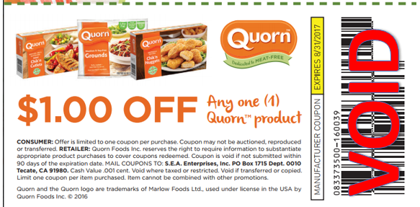

Misprinted Coupon
Effective: Immediately
Palermo’s, Inmar Dept. #75706, currently has an offer 022084 in circulation on the back of a Brewer’s ticket without a redemption address. Please forward all coupons for this offer code to the following address:

Palermo’s
Inmar Dept. # 75706
One Fawcett Drive
Del Rio, TX 78840
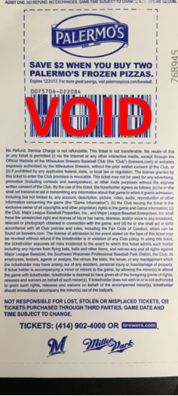

Coupon Clarification
Effective: 7/10/17
Clarion Brands, Inmar Dept. #89476 currently has a coupon in circulation, offer #100049,
that is scanning for $2.00 but the coupon reads "$3.00 off".
The manufacturer will honor the $3 value that is stated on the coupon.

Clarion Brands
Inmar Dept. #89476
One Fawcett Drive
Del Rio, TX 78840
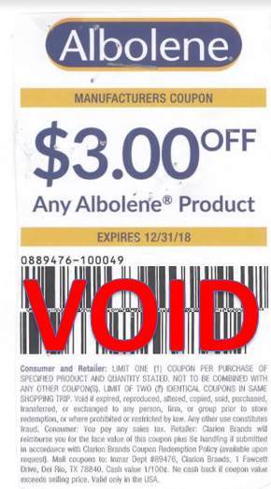

Misprinted Coupon
Effective: 7/10/17
Dole Fresh Vegetables, Inmar Dept. #71430 have 3 coupons in circulation, offer codes 178580, 178581, and 178582 that have a misprinted redemption address in the legal copy that states to mail the coupons to Dole Packaged Foods, Inmar Dept. # 38900.
These coupons should be sent to the address below.

Dole Fresh Vegetables
Inmar Dept. # 71430
One Fawcett Drive
Del Rio, TX 78840


Coupon Clarification
Effective: 7/20/17
Weetabix-Barbara’s Bakery, Inmar Dept. #70617 currently has a coupon in circulation, offer #100214,
that is scanning for $0.01 but the coupon reads "$1.00 off".
The manufacturer will honor the $1.00 value that is stated on the coupon.

Weetabix-Barbara’s Bakery
Inmar Dept. #70617
One Fawcett Drive
Del Rio, TX 78840
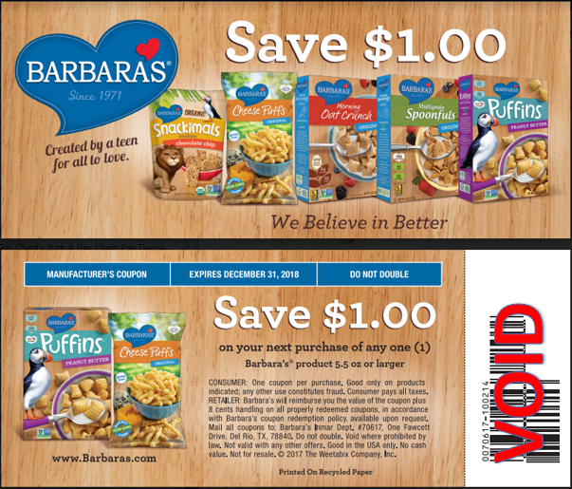

Terminated Client
Effective: 7/20/17
Previous Address: | New Address:
Takeya USA  Inmar Dept. #85395  One Fawcett Drive  Del Rio, TX 78840 | Takeya USA  214 5th Street  Suite 204  Huntington Beach, CA 92648  Attn: Lauri Acosta

Terminated Client
Effective: 6/30/17
Previous Address: | New Address:
Hoyu USA  Inmar Dept. #12102  One Fawcett Drive  Del Rio, TX 78840 | Hoyu USA  6265 Phyllis Drive  Cypress, CA 90630  Attn: Jeannine Balladares

Terminated Client
Effective: 7/26/17
Previous Address: | New Address:
Wenner Media  Inmar Dept. #99770  One Fawcett Drive  Del Rio, TX 78840 | Wenner Media  1290 Avenue of the Americas  2nd Floor  New York, NY 10104  Attn: Linda Greenblatt

Terminated Client
Effective: 7/29/17
Previous Address: | New Address:
Alpina Foods  Inmar Dept. #83322  One Fawcett Drive  Del Rio, TX 78840 | Alpina Foods  3750 North West 87th Avenue  Suite 450  Doral, FL 33178  Attn: Anya Sarkisov

Terminated Client
Effective: 7/11/17
Previous Address: | New Address:
Ploom/Pax Labs, Inc.  Inmar Dept. #52605  One Fawcett Drive  Del Rio, TX 78840 | Ploom/Pax Labs, Inc.  600 Alabama Street  San Francisco, CA 94110  Attn: Kim Reyes

